- Login page

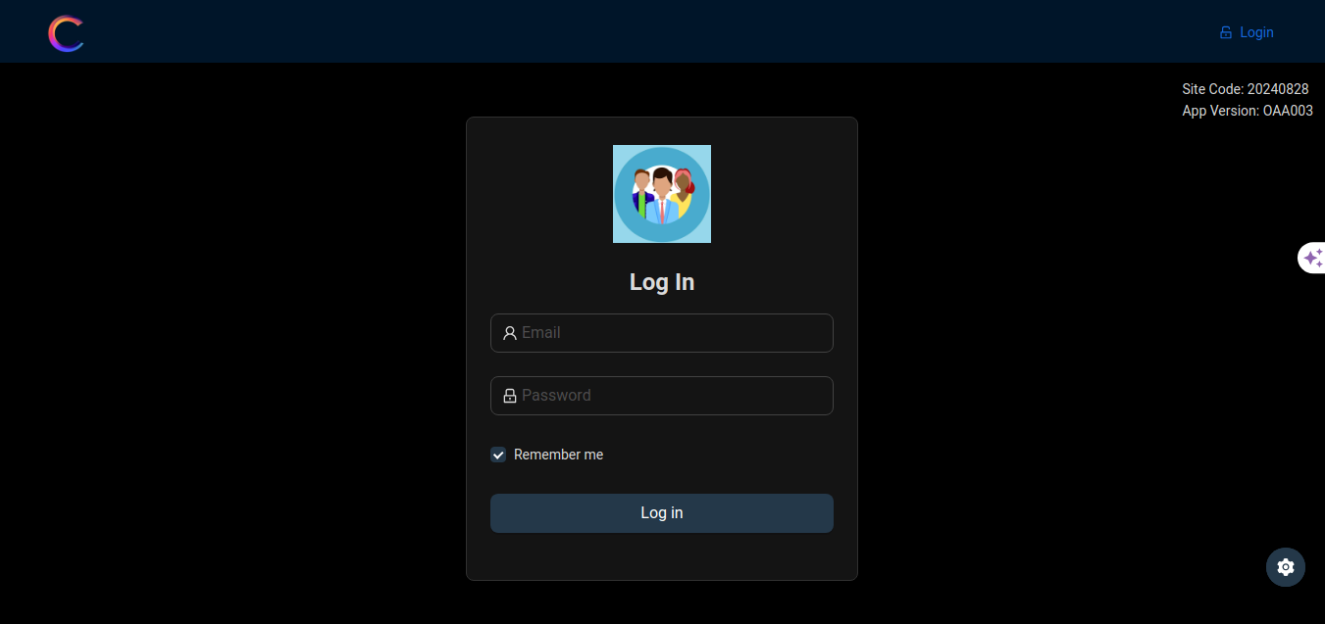

Login logo is square and no size updated. And site code, app version added in correct place.  
Please create your logo to be displayed in login page and send it to me.  
I will upload the logo for this.  
  
- Admin’s setting page

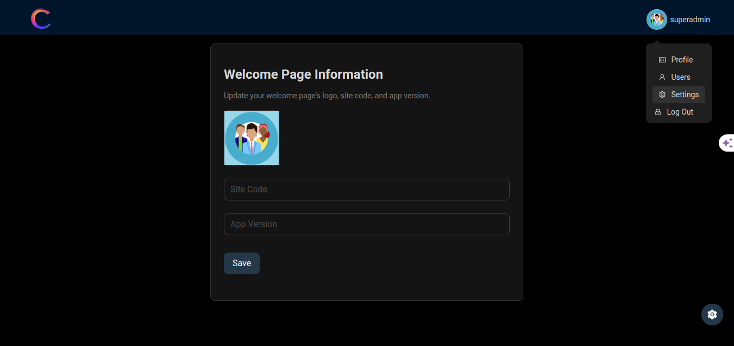

I added new menu named settings, which manages all logo and detail upload.  
Currently I added login page’s detail management here, admin can upload welcome page’s logo, site code and app version.

\* To do lists \*

Here we need to add entry page detail upload management. You early mentioned about entry page’s logo, and detail. Please provide the design of admin’s entry page detail upload.  
As we are in process of 2nd milestone, so please provide this step’s upload detail.

- Entry page(personal entry)

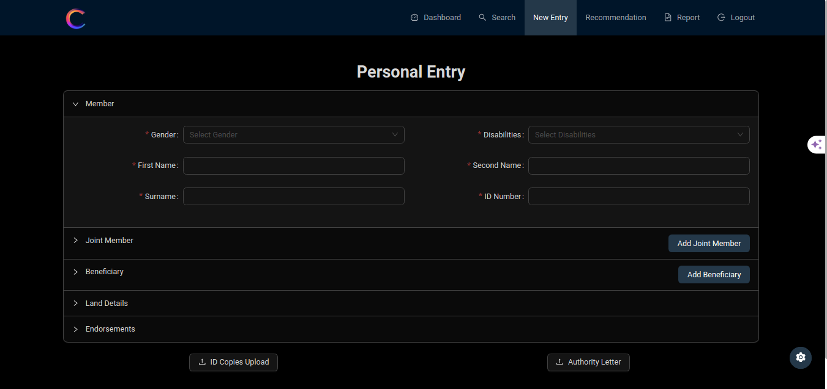

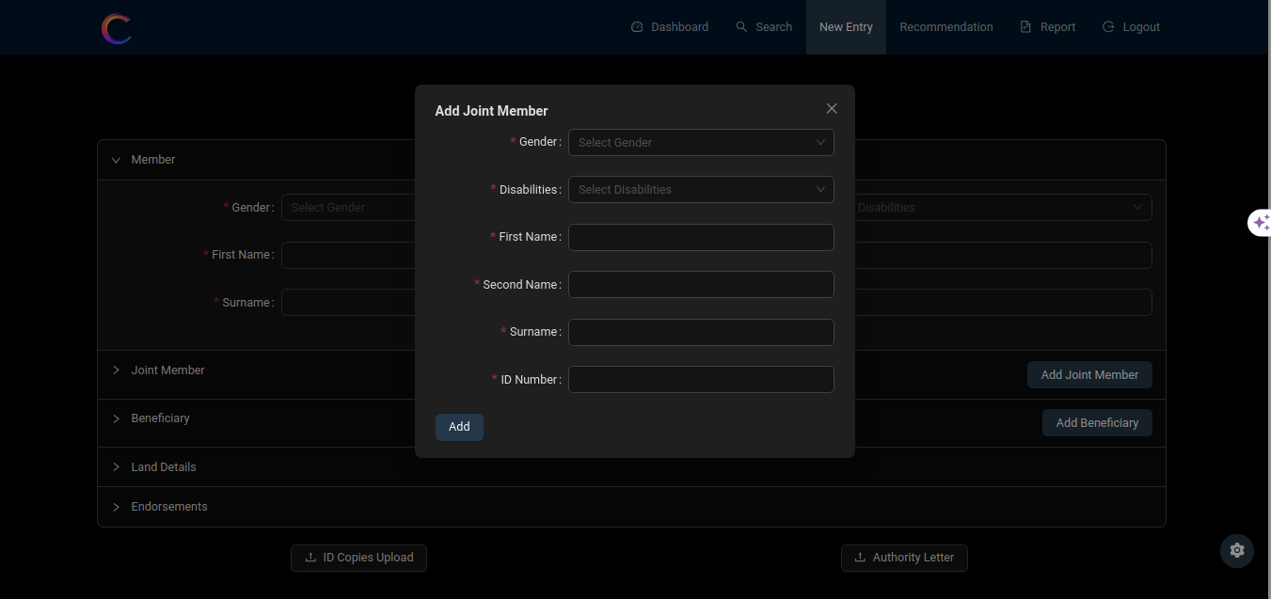

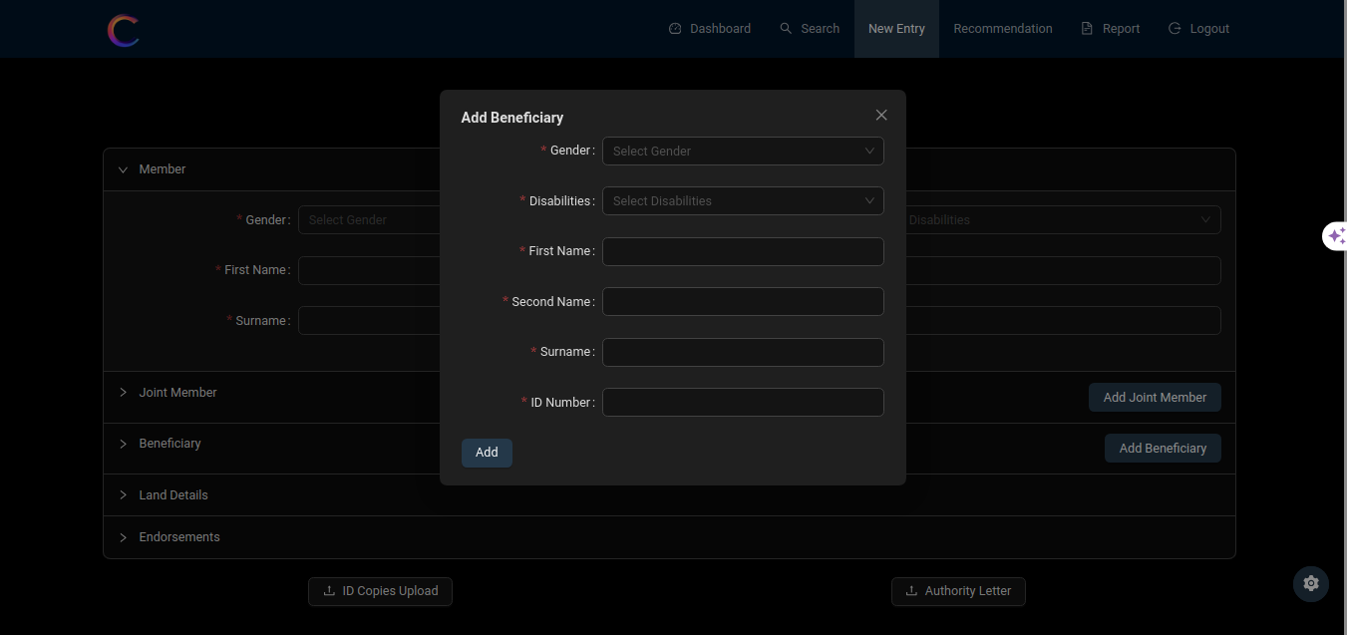

I added button to add new joint member and beneficiary modal, this is what you want? Once office manager fills all data in inputs, then let me know the result of save, print, cancel button’s actions.

- Business entry too.